**Crypto Wallet & Trad UI**



**Project Installation Guide:**

1. Install VS code.
2. Install Flutter frameworks.
3. Unzip Crypto Trade Folder and open in VS code.
4. Go to pubsec.yaml file and fetch Data.
5. Build Code.
6. Get your output on your Devices.
7. Put your Coin market API Key
8. 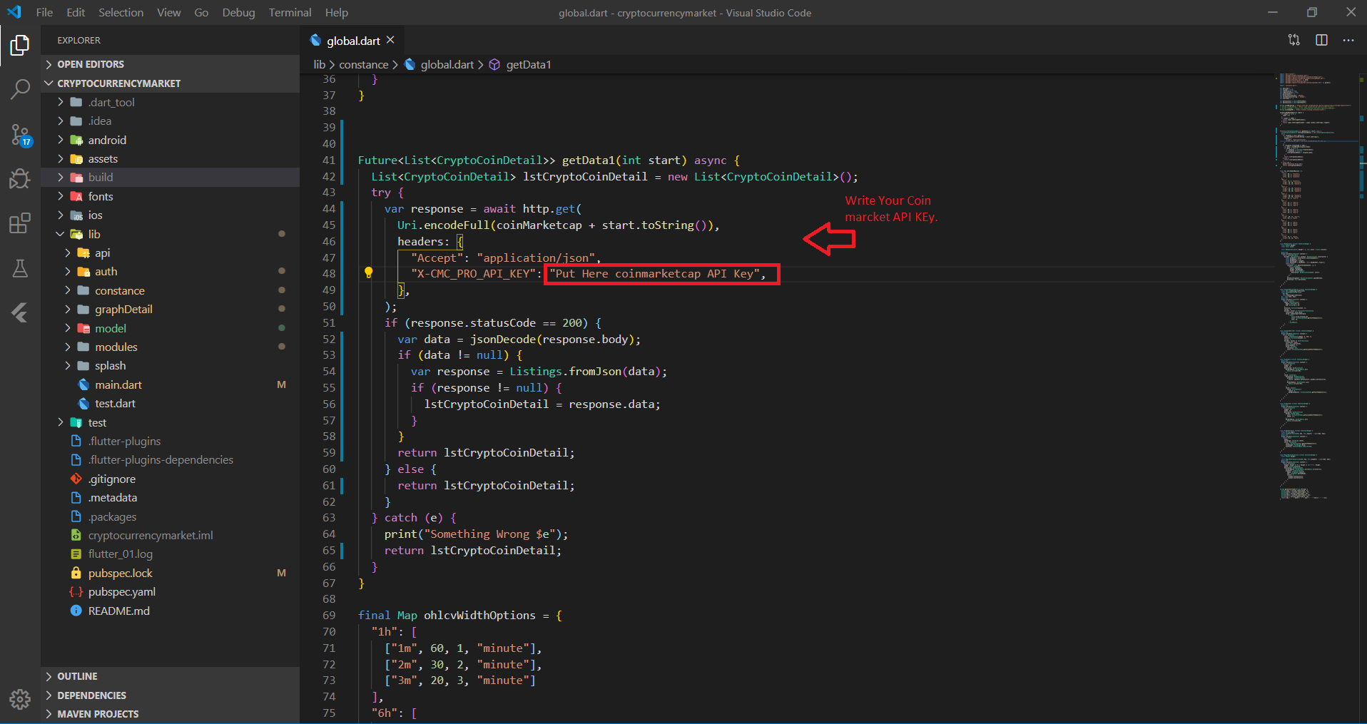

**Project Description:**

Flutter is an open-source mobile application development SDK created by Google. It is used to develop applications for Android and iOS, as well as being the primary method of creating applications for Google Fuchsia, Flutter widgets incorporate all critical platform differences such as scrolling, navigation, icons and fonts to provide full native performance on both iOS and Android.

Crypto and Wallet UI kit can be used for Crypto and Wallet theme application in android and iOS device. It contains 30+ Screens with different type of UI, Crypto and Wallet UI kit can be saving your time to code all Front-end layout. Easy to connect with your back end.

In Crypto trade Application full application is Animation with smooth effects. Also use magic Animated Colourful widget.

**Crypto Trade & Wallet UI Kit Features:**

* Clean Codes and UI
* Clean Design
* Smooth Animations in every screen
* Responsive Design for all Devices Screen
* Easy to custom lay outs
* Live Cryptocurrency Prices API
* Live Cryptocurrency Coins Details
* Live Stock Detail using APIS
* Live trading pair APIS with details
* Live Buy/sell Details with volume
* Wallet system & Trade Wallet
* Animated Charts
* Set Schedule time
* Animated Deposit/Request payment with Barcode
* Withdraw payment Animated Screen
* Live Crypto cryptocurrency News using APIS
* Beautiful Screen lock Pattern
* Animated navigation Drawer & Beautiful Bottom Custom tab bar